Introduction
Audience: Parent/Guardians of FBISD Students
Purpose: To obtain a student’s Unique Access Code for state assessments in Family Access

Screen Resolution and Web Browsers
Below is the recommended screen resolution and supported web browsers for Skyward Family Access.

Screen Resolution
Family Access is best viewed at a minimum screen resolution of 1024 x 768.

Supported Web Browsers:
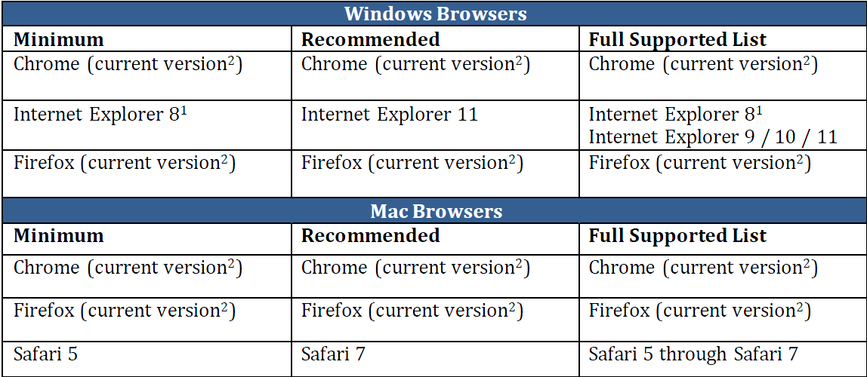
As of 9/16/2014
Step 1
Begin by going to the FBISD website at http://www.fortbendisd.com/family-access
Χlick on the Login to Family Access link on the right side.
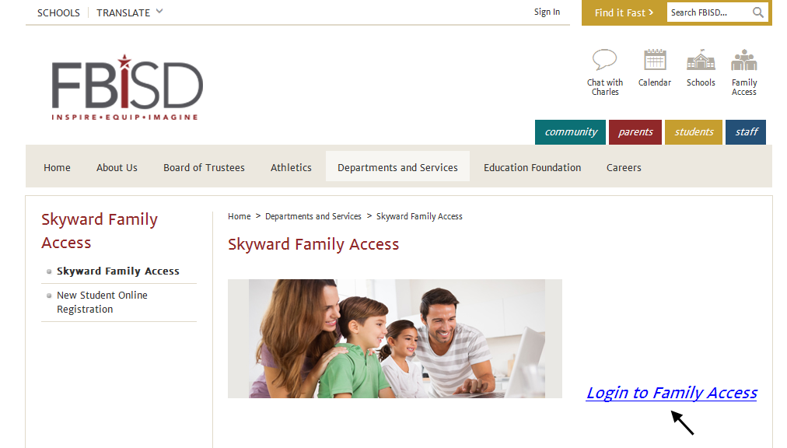

Step 2
When the login screen opens, enter your login and password, and click on the Sign In button.

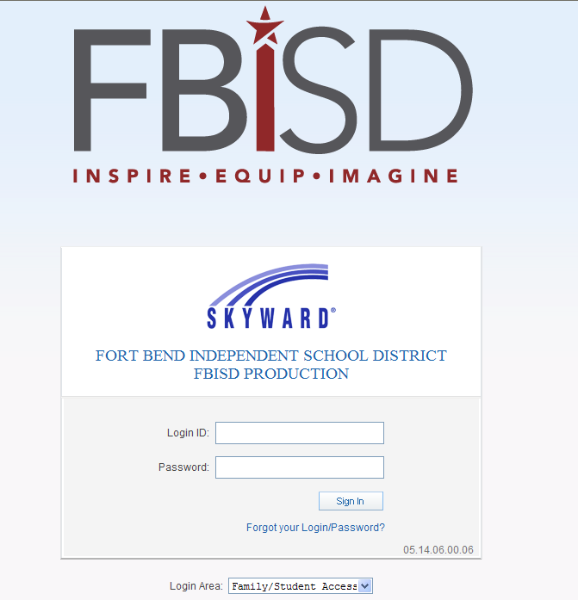
Step 3
Τηε Φαμιλψ Αχχεσσ ηομε παγε ωιλλ δισπλαψ. Ον τηε λεφτ σιδε, χλιχκ ον Πορτφολιο.

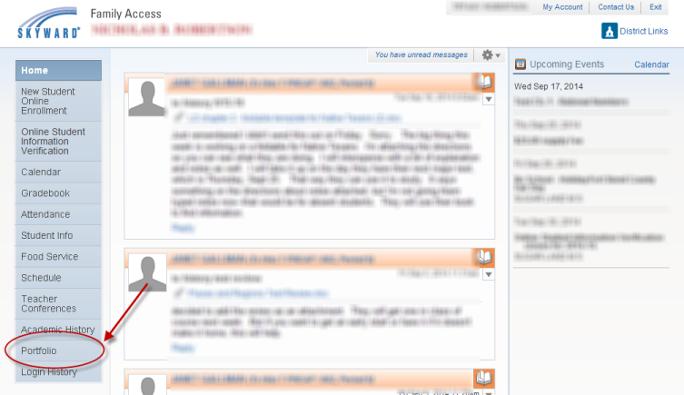
Step 4
A list of attachments will display. Click on the report named Access Code – Texas Assessment Portal (for the student’s CURRENT school).

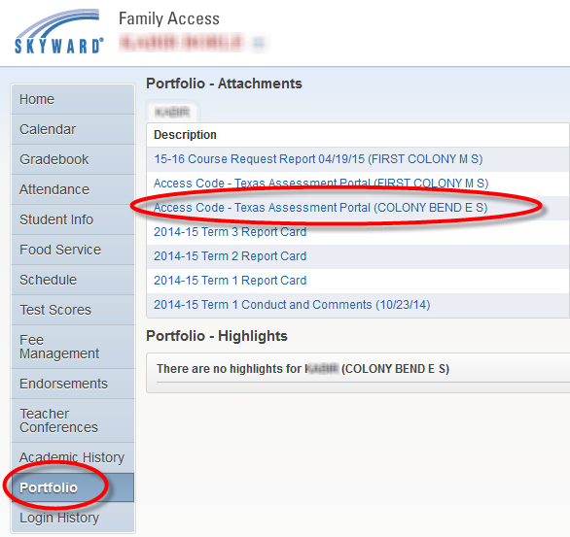

Step 5
The report will generate. Click on View Report when complete.

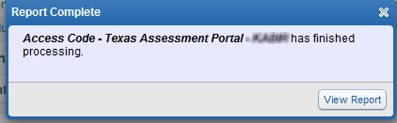

Step 6
Below is an example of the report.

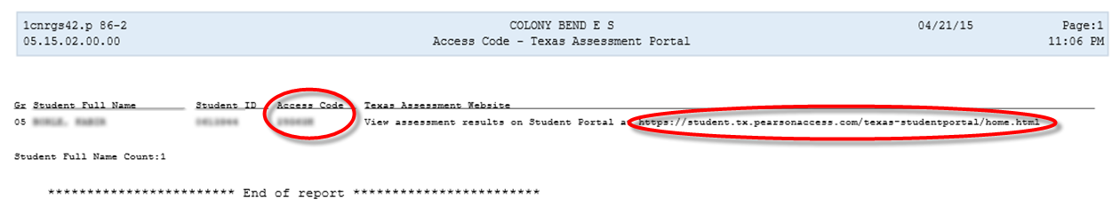

Step 7
Copy and paste the URL into your web browser.

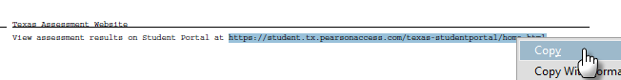

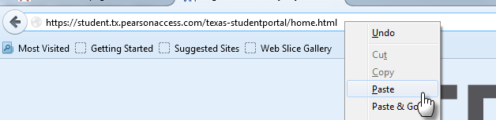

Step 8
Use the Unique Access Code to log into the Student Assessment Portal.

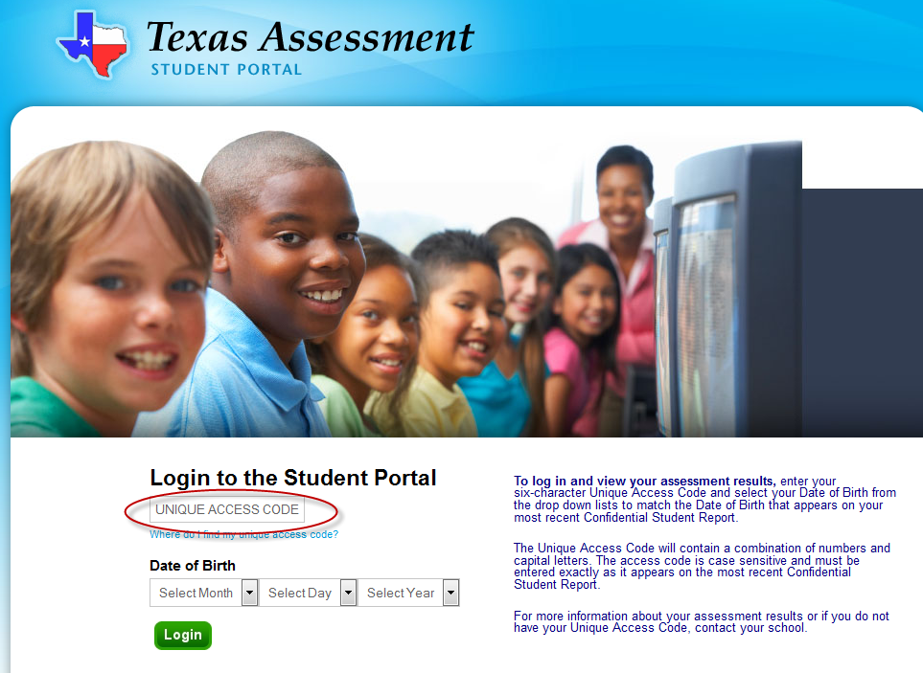

End Process

